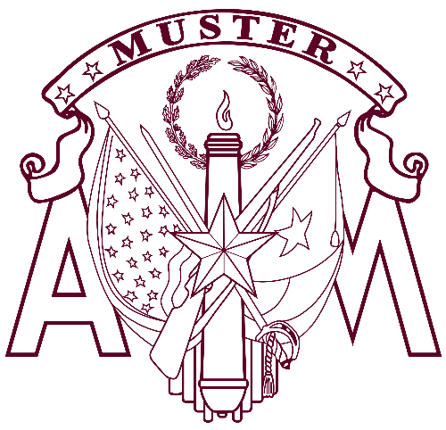

April 21, 20xx
Your City Here

YOUR A&M CLUB HERE

Welcome To Aggie Muster
Howdy! Your presence here upholds a tradition
that is more than a century old. Aggie Musters are taking place this month at more than 300 sites around the world.
Every Muster is different. Some are dinners;
some are picnics; some are held on beaches or in barns.
Most will include a Roll Call of the names of Aggies who
have passed away since the last Muster. When a name is called, all those who knew them may answer “Here.”
Muster serves dual purposes: to renew our ties
as Aggies throughout our lives, and to affirm that those
who have passed from our ranks remain present in our hearts.

Share Your Muster Photos
The Association of Former Students would love to see
and share pictures and videos that you take. You can upload
them at tx.ag/MusterPhotos or tx.ag/MusterVideos;
please include the location or name of your Muster.

Have further questions?
Visit tx.ag/MusterFAQ

Program
Welcome
The Aggie War Hymn
Invocation
“The Muster Tradition”
Introduction of Speaker
Muster Speaker
“The Last Corps Trip”
“Roll Call for the Absent”
Roll Call
Silver Taps
“In Memoriam”
The Spirit of Aggieland
Closing

“If there is an A&M man in one hundred miles
of you, you are expected to get together,
eat a little, sup a little, and live over the days
you spent at the A&M College of Texas.”
~ Texas Aggie magazine, 1923

