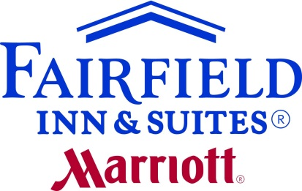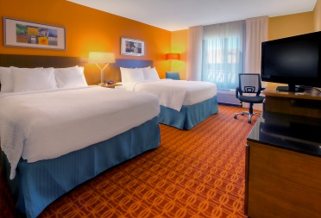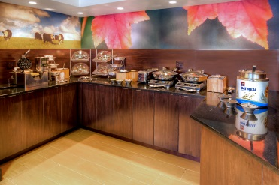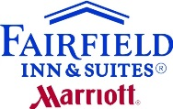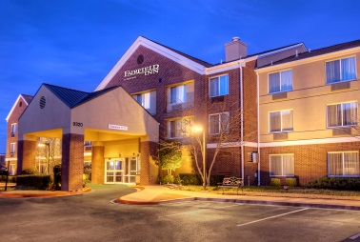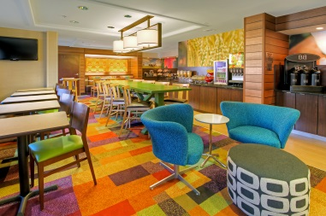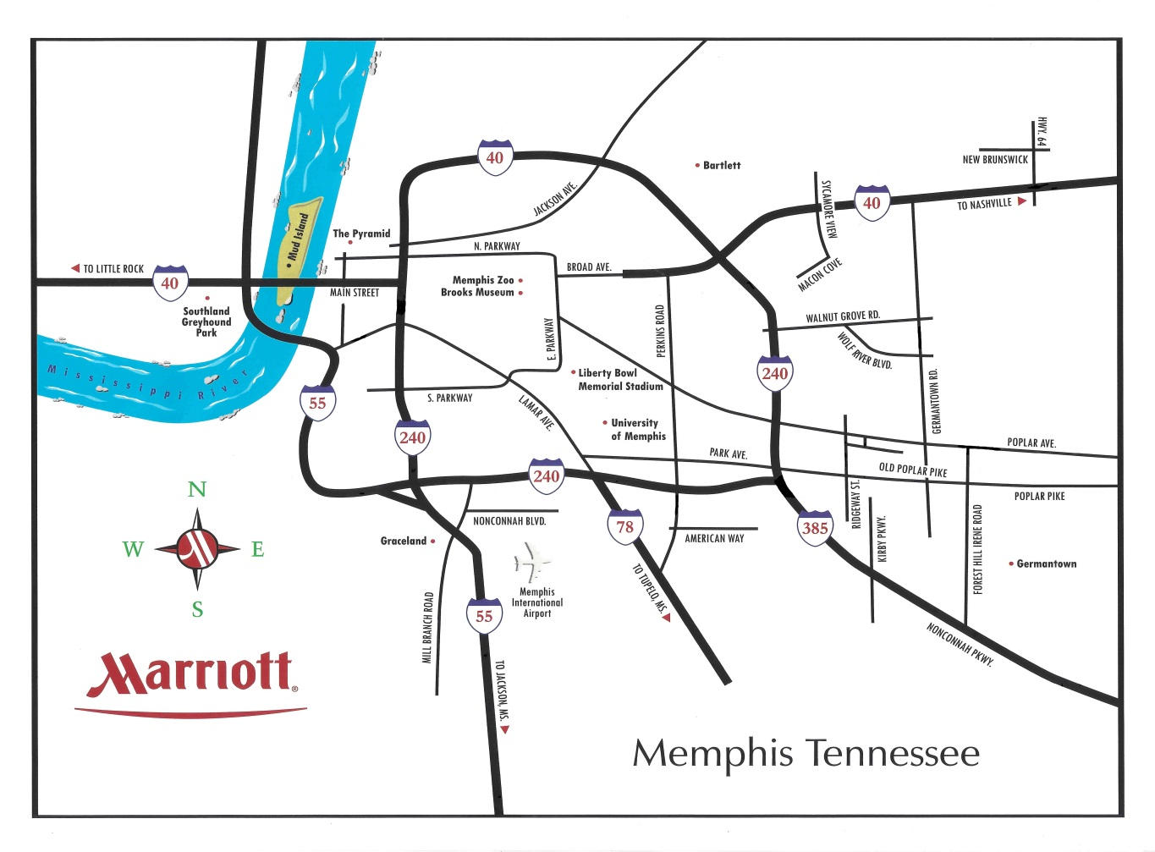



Rates from $99

(per night, plus tax)

Newly Renovated!

Only 25 minutes from the Liberty Bowl Memorial Stadium.

Enjoy our indoor pool and spa.

Wake up to a complimentary hot breakfast with eggs, sausage, waffles, and lots more!

9320 Poplar Pike

Germantown, TN 38138

901-757-9100

www.fairfieldinngermantowntn.com