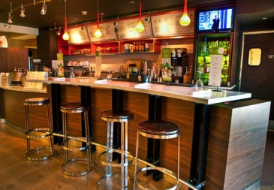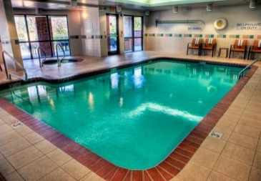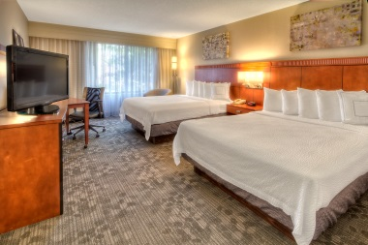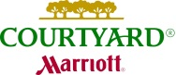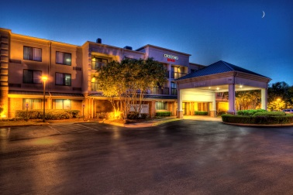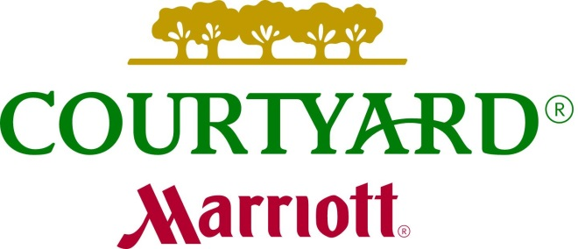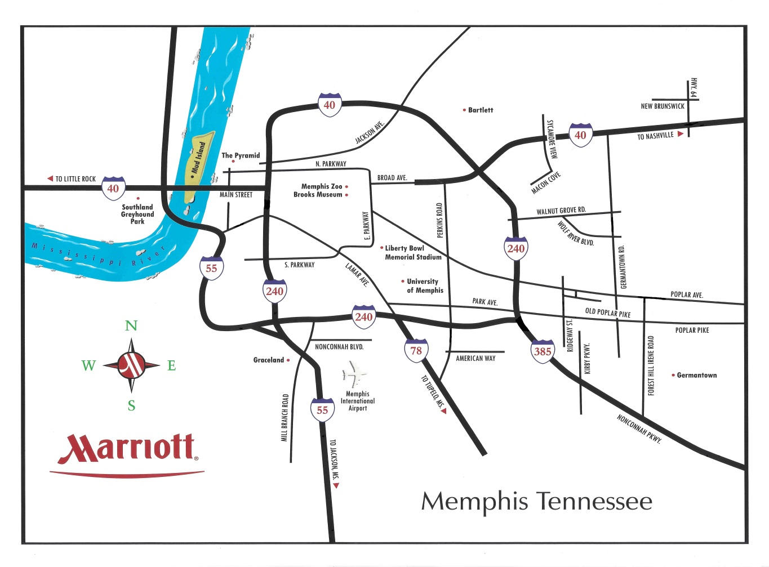

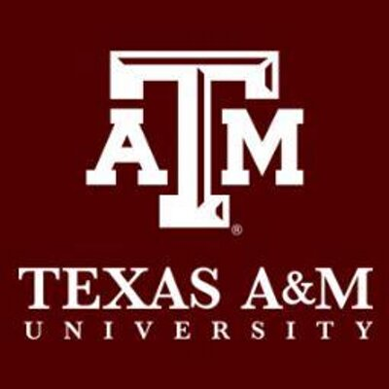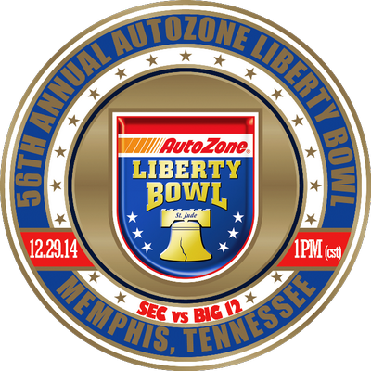

Newly Renovated!

Only 17 minutes from the Liberty Bowl Memorial Stadium

Enjoy Starbucks coffee in our Bistro. The Bistro serves cooked to order breakfast and evening meals. The serve cocktails and beer in the evenings as well.

Rates starting at $129

per night, plus tax

7750 Wolf River Blvd.

Germantown TN 38138

901-751-0230

www.courtyardgermantown.com